

Mathematics Department |  | 
Course: A2MAA
Topic Title: Test 2 Calculator Free
Student Name:_____________________________________ | Date: ____________
Special Instructions: Formula Sheet allowed and no calculators | Time Allowed: 50 minutes
Show all working clearly | Marks: / 50

Question 1. [2,2,2,3:9 marks]
Solve following

a) $5x-8=42$ b) $4x-3=2x-11$

c) $28x-6\left(3x-5\right)=40$ d) $\frac{x+5}{3}=(2x+5)$

Question 2. [2,2,2:6 marks]
Determine equations of the straight lines shown below
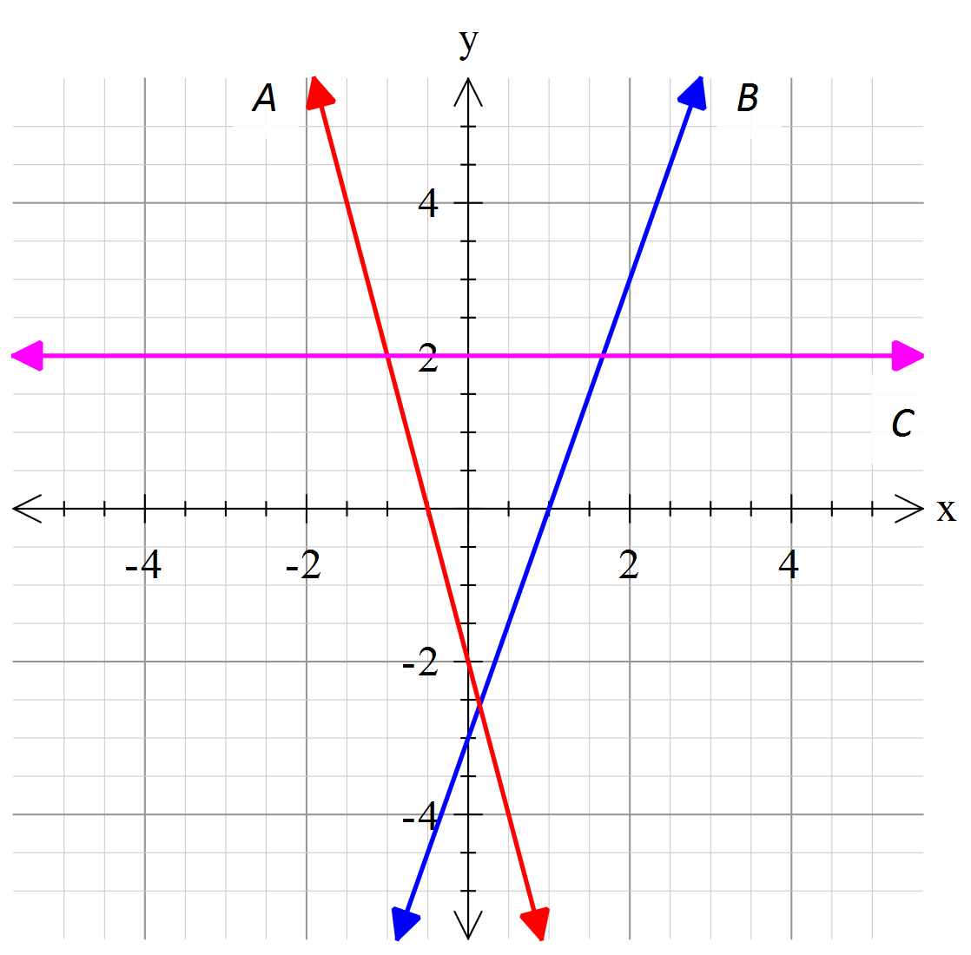

A = ________________________

B = ________________________

C = ________________________

Question 3. [3 marks]
I think of a number, double it, reduce it by 7 and divide it by 3. The result is 17.
What is the number?

Question 4. [4,2,6:12 marks]
a) Determine the equation of the straight lines with the following properties:

(i) Has a gradient of -3 and y-intercept of 4. (ii) Has a gradient of 5 and y-intercept of -1.

b) Determine the equation of the straight line that has a gradient of -2 and passes through the point (0,5)

c) Determine the gradient and y-intercept for each of these lines

(i) $y=3x-2$ (ii) $y-12=-2x$ (iii) $2y=-6x+4$

Question 5. [4 marks]
Graph the following functions
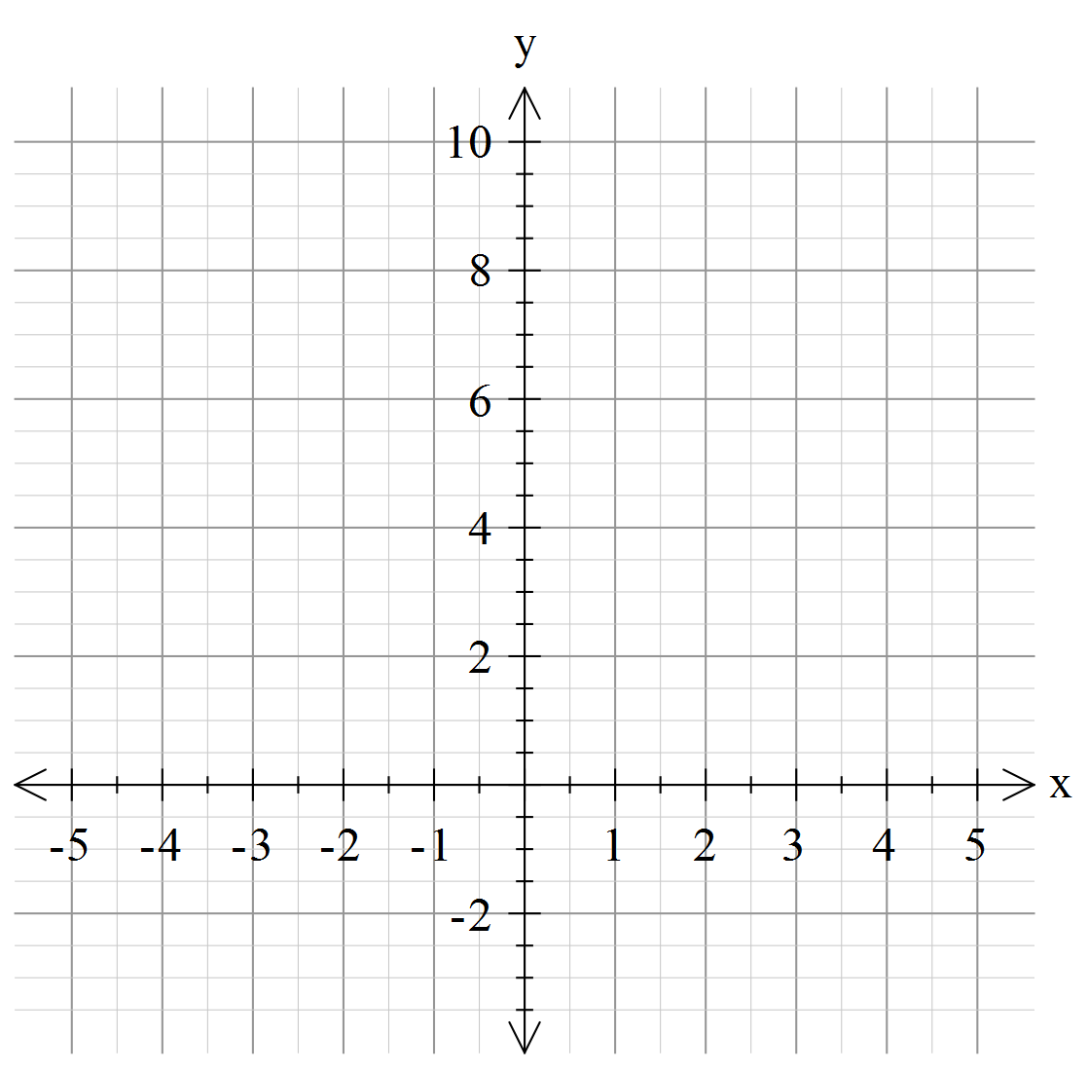
a)
$y=\left\{\begin{aligned}8, &-4<x≤-1 \\ -1, &-1<x≤0 \\ 2, 0<x≤3 \\ 4, 3<x≤4\end{aligned}\right.$

Question 6. [3 marks]
A wedding singer charges $200 plus $60 an hour for her services. Construct a linear graph to
show the cost ( C ) of the singer for ( h ) hours.
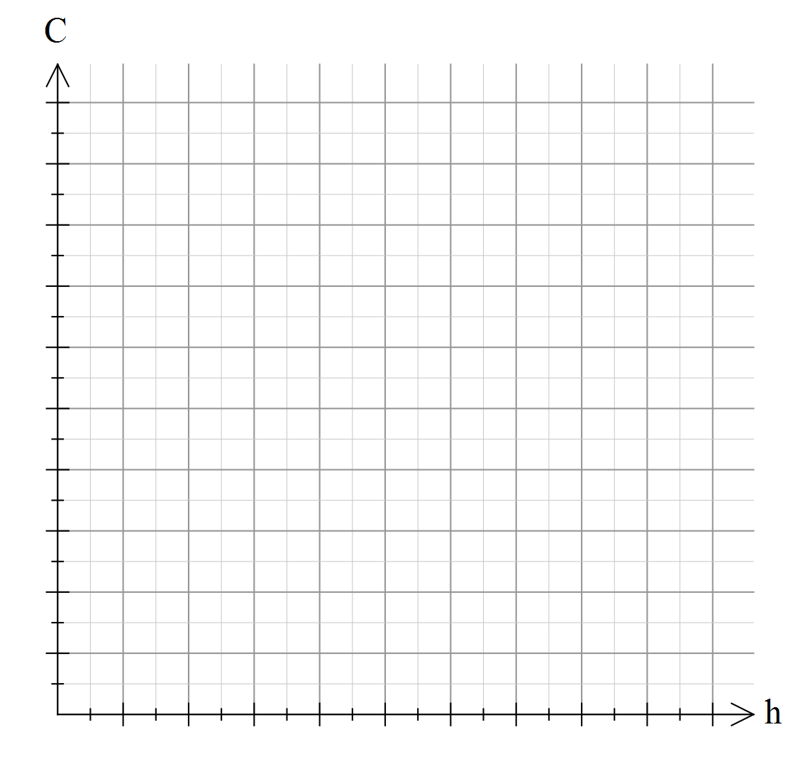

Question 7. [3 marks]
Consider the chart below showing the cost of an international phone call from
Australia to Belgium.
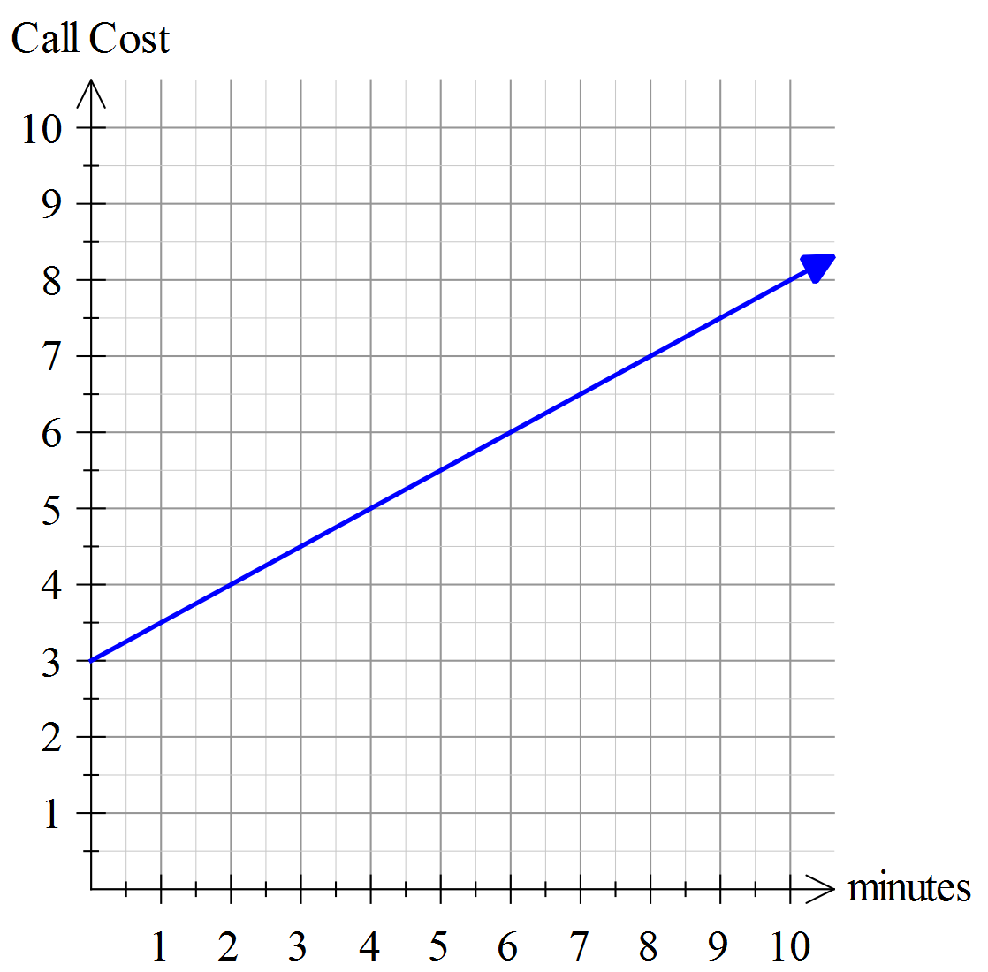

a) What is the gradient of the line?

b) What is the y-intercept of the line?

c) Describe the cost of a phone call to
Belgium using your answers from (a) & (b)

Question 8. [4 marks]

The entry fee to the annual Agricultural Show is charged according the patron’s age.
Use then information provided to complete the table and the step graph shown below.

Ticket Prices
Age (years) | Cost
0 – 2 | Free
3 - 11
12 – 17 | $10.00
18 - 54 | $14.00
55 plus
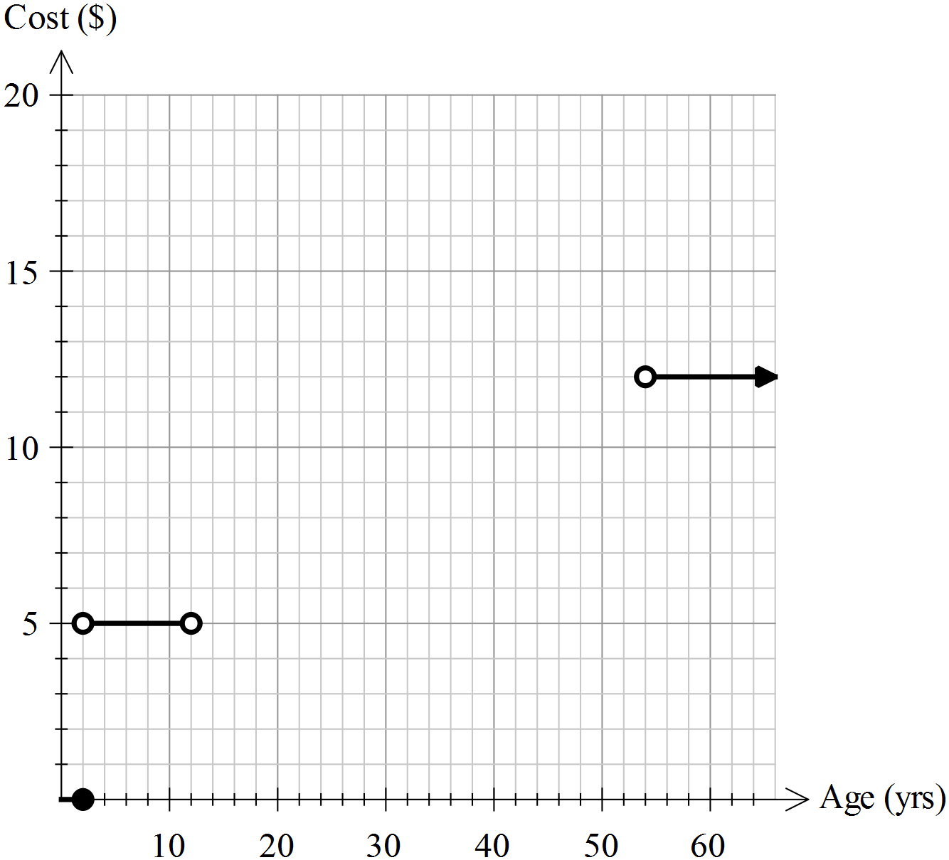

Question 9. [6 marks]

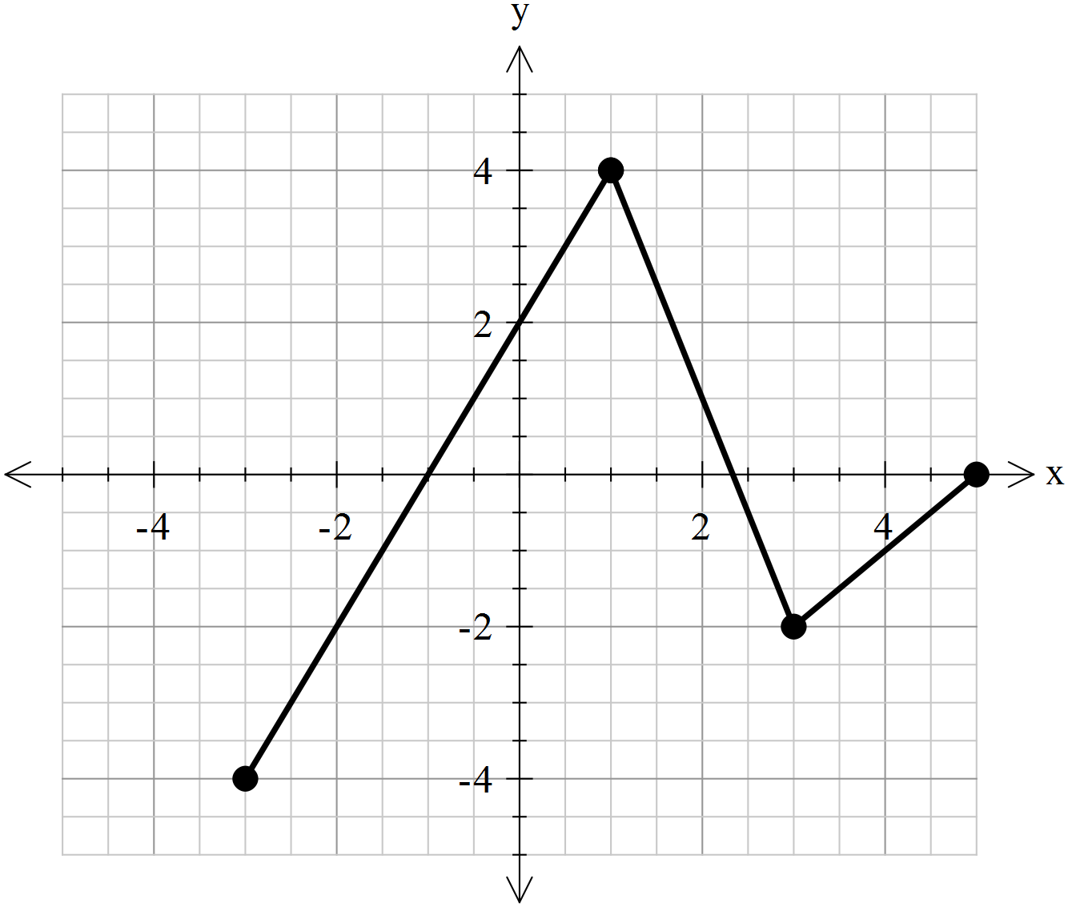Write an equation for the piece wise function

_________________________
$y =$ { __________________________

__________________________

